ACTIVITY GUIDE
DAY 1
PORTRAIT GAME
Purpose: To get the participants know each other using a very relaxing method. This session is meant to get the participants know their fellow participants. This is done by doing an activity of having the participants draw their faces and then introduce their partner. This activity elicits a laugh, make people feel welcome and relaxed.

Process: Explain that you are now going to test the drawing skills the participants acquired in kindergarten school. They have to follow the following steps
.
Step 1 Distribute a A4 size paper and a permanent marker to each participant.
Step 2 Each person draws his face using the marker .
Step 3 Find a partners and share full information i.e. name, organisation and title so that they can be introduced fully to the class. They can also say which name they want to be used in being addressed in the training.
Step 4 Each participant stands and introduces his or her partner
Step 5 After all the introductions every one sticks the portraits on the wall.

Debrief: It’s very important that you summarise some of the key characteristics such as organisations and gender composition of the participants.

WHY SOCIAL PROTECTION? DEVELOPING SCENARIOS
Purpose: To have delegates brainstorm on individual and societal impacts of SP. To lure participants out of their current comfort zones relating to typical SP chains of events and change theory through developing ‘complicated’ scenarios. See also ‘Learning debrief’ below.
Process: Invite participants to gather in 4 mixed groups: groups 1&2 will focus on the ‘positive outcomes’ of receiving cash and groups 3&4 on the ‘negative outcomes’ of not receiving it. Ask them to nominate a ‘facilitator’ (supported by the rest of the team) within each group as well as two ‘complicators’. Now follow the briefs for each type of group here below.
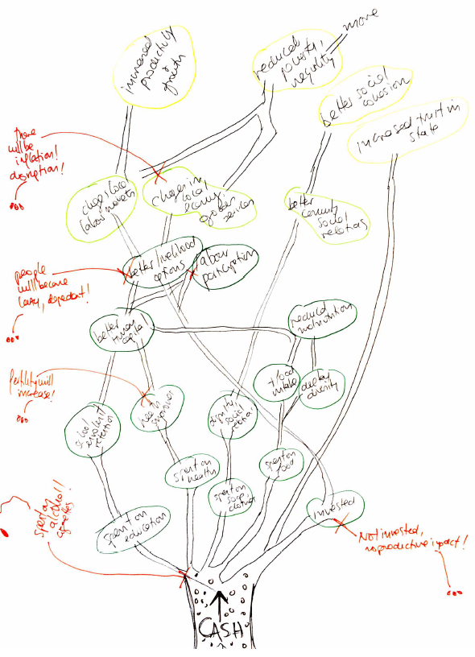
Groups 1 and 2 ‘Positive Outcomes’ of receiving cash transfer
Question (on slide): Imagine this woman receives cash for social assistance. How does that affect her, her community and society at large? Develop a scenario in the shape of a tree depicting how the possible chain of events could unfold.
- Brief for facilitator and group: Develop a theory of change thinking about positive impacts at individual, community and especially societal level. Represent each ‘impact’ as a leaf on a branch, growing upwards: individual impacts in one colour at the bottom, community impacts in another colour in the middle and societal impacts in a third colour at the top (see image). The group also needs to be responding to the provocations of the two complicators as they build their ‘tree’.
- Brief for complicators: complicators need to put spanners in the wheels of the facilitator and his/her team by drawing on anecdotal evidence of cash transfers not working or triggering negative behaviour (think about newspaper articles, widely held beliefs!). At each level, they need to be thinking: what could go wrong? These inputs are then added in red as leaves falling off the tree.. see image. Examples could include: money being spent on alcohol and cigarettes, cash making people lazy and dependant, etc.
Groups 3 and 4 ‘Negative Outcomes’ of not receiving cash transfer
Question (on slide): What if she does not receive the cash? What would happen then? Develop a scenario in the shape of a tree depicting how the possible chain of events could unfold.
- Brief for facilitator and group: Develop a theory of change thinking about negative impacts of not receiving that assistance at individual, community and especially societal level. Represent each ‘negative impact’ as a root of a tree, growing downwards: individual impacts in one colour at the top, community impacts in another colour in the middle and societal impacts in a third colour at the bottom (reverse of image above). The group also needs to be responding to the provocations of the two complicators.
- Brief for complicators: complicators need to put spanners in the wheels of the facilitator and his/her team by drawing on anecdotal evidence to show that social protection is not needed to support her, as other policies can and will play this role. E.g. economic growth at national level will trickle down to her, quality education (e.g. pre-school for her kids) is all she needs, etc. they will draw these in RED and add them to the roots picture.
Give small mixed participant groups 20 min to develop their scenarios on a flip chart showing the sequence of events, and how one things leads to another on the personal, community and society at large level. Walk around the groups to observe their progress and clarify any questions they may have.
Debrief (what): Let each group’s spokesperson present the most important and the most contested aspects of their scenario, ideally focusing briefly on each level.
Learning debrief (so what, now what): Ask participants what they have learned from the exercise, or draw this out yourself, with key learnings including: a) social assistance may be catered at individuals and their households, but can have strong societal impacts (e.g. social cohesion; b) there are many negative associations around SP, but these are mostly rooted in fears, beliefs and anecdotal evidence: one falling tree makes much more noise than a whole forest growing.
Then use slides to confirm that there is substantive regional evidence supporting these pathways and debunking some of the myths.

DRIVERS OF SUCCESS AND RESTRAINING FORCES FOR CHANGE IN SOCIAL PROTECTION
Purpose: To reflect on what can prevent/hamper the establishment of national systems of SP in Africa. Divide into 2 groups, the other group at policy level and second group on operation level.
Process: Delegates are shown the slide showing a traffic light. They are then given a pile of green and a pile of red cards. They work at their tables brainstorming drivers of success (green) and restraining forces (red) – writing one driver per card.
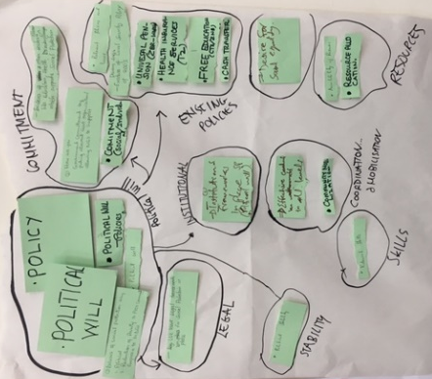
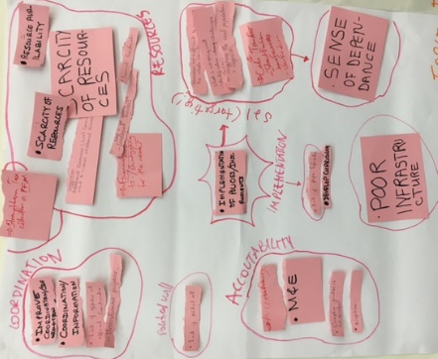
Debrief (what): The facilitator invites each group’s spokesperson to present their cards in plenary and add to two flipcharts – one for green cards, and one for red cards – grouping new inputs with previous ones where possible and creating new groups if necessary. Once all cards have been presented, the clusters of forces can be ‘circled’ in pen and given a name (see image), ideally one that easily maps back to the ‘Building Blocks’ of the SP web. There should be a visual representation of the strength of each area (e.g. in picture all groups said lack of resources was an issue and most said there was strong political will).

Learning debrief (so what, now what): Once all cards are clustered, facilitator discusses what the overall picture is showing: e.g. every group believes X and Y are serious constraints, while few people mentioned Z. One important take-away may be that we often focus on lack of resources as a constraint, but forget lack of staff and capacity at local level. Explain that this is a static picture of the status quo, but this does not mean we are stuck where we are now. Over the course of this curriculum we will have time to think how to shift the status quo if it does not respond to our needs.
Also stress that this map automatically leads to the next activity, which focuses on the key building blocks of an SP system (e.g. lack of resources.. strong legal framework, etc)…

THE MAIN MESSAGE : policy makers have a responsibility to weaken the constrainers and strengthen the drivers/ so as to move the arrow to the left.

JOLT
Options:
- The folded toot picks jolt: Take 5 tooth picks and fold each of them without breaking it; put them together to make a circle with sharp sides pointing outside the circle. The central space should all be filled up/no much space left. Take a syringe of plain water and start dropping at the center (space). Keep adding drops…You will observe a slow expansion of the circle into a very nice star.
- Place similar sized small money coins on delegates tables. Start by cracking a question: Guess: how many drops of water can fill up the top of a coin? Observe responses in the room and write the guesses down. Now, ask the participants to: take a coin and a syringe of plain water. Start adding one drop after drop of water on the coin. Count the drops and observe the difference between the actual counts and the guesses.
- Fill stones in a glass and add gravel then sand or sugar and they notice that it is still not full and then later fill in some more…once is really full then add water or (beer) and enjoy it.
Key Message: To emphasize that as policy makers they may think they have everything but they need to expand beyond horizons.

INTRODUCTION & VOTING:
- The Building Blocks of an SP System
- SP Admin System components

Purpose:
-Let the delegates give us the priorities of the modules and sub-modules that they absolutely don’t want to miss
-Let policy makers reflect on the administration system in its entirety and to also highlight in which parts of the systems to they think there are challenges, main hurdles.
Process: display the next slide and have participants place stickers beside various admin components including M&E, MIS to vote for which they see having serious problems.
- (Could be done interactively with star stickers to be applied to the main systems diagram). Prepare the flip chart with the admin framework.
- Discuss what criticalities they think exist in the administration.
- Based on this you could select to give them some nuggets of knowledge for the areas they feel are more crucial.
- Need to create a table or prepare on a flip chat.
To conclude.. Lets remember this all happens at programme level

WORST CASE SCENARIO (It has now been removed from the slides; Add it back if there is time).
Activity: Mamba is a democratic country located in the pacific ocean whose economy is powered by the blue economy (export of sea food) and iron. Mamba has 23 ministries and among these, the Ministry of Social Development was for more than 40 years treated as a “by the way “ and was not considered critical to the development of Mamba country. Despite Mamba posting an economic growth rate of 6 percent for the last 10 years poverty had remained pervasive and endemic. Through the sustained efforts of the development partners , social protection has moved up the development agenda and has seen 1900 percent budget increase to the Ministry of Social Development in the last 5 years.
The Ministry is now implementing the pensions for older persons (given to anyone above 65 years) reaching 650,000 individual beneficiaries. The ruling government has seen its approval ratings go up tremendously. Donor funds are pouring in at unprecedented rates. The donors are providing 30 % of the pension funds.
The Ministry is does not have a law that provides for the creation and management of pensions for older persons. The administrative guidelines were developed by the Ministry but are weak as they are flouted from time to time by the Minister (His comments is that guidelines were meant for the programme and not vice versa). The Chief Accountant though highly qualified for the job has been told and convinced that the Ministry was the ministry of the poor and as such some payment decisions had to be made in the interest of the poor and not always follow the financial regulations to the last letter. The Internal Audit Unit has been accused of standing in the way of development by questioning too many payments. The Chief Secretary to Cabinet who is a Presidential appointee has not been able to provide adequate protection to the Chief Accountant and the Internal Auditor.

Instructions
Given the above governance systems what could go wrong and in what ways?
What would be the worst impact if something went wrong? What would be the worst case scenario ?
Suggest measures of preventing the worst case scenario from happening ?
SIMULATION ROLE PLAY ACTIVITY
Purpose: To afford the delegates an experiential opportunity to see SPF from the perspective of those beneficiaries they serve through role playing, to see potential for shifting their beliefs
Process: Give same set of 6 cards to 2 groups and also another set of 6 cards to 2 groups. We want to see if they will arrive at the same beneficiaries. If the 2 groups working on the same set of cards can choose different beneficiaries, then they will appreciate more the complexity of selection. Tell them to think carefully about the character on their card (Where do they live? When did they last eat? What might they hope for? How much can they do to change their situation, if they wanted to? etc.) and prepare for a roleplay discussion.

The groups should discuss how social protection should be distributed amongst them in the group – because (show slide) ONLY 3 of them can receive it.

Simulation Role play Character Cards.
22 year old HIV+ man, unemployed, living in a squatter settlement 20km from city centre | Owner of a shop in the countryside, the only one for miles, who charges very high prices and offers credit
20 year old unemployed male, recently released from prison after serving a sentence for house-breaking | High-functioning young woman of 19 with Down’s Syndrome (mild to severe retardation) from a wealthy city family
Under-age male migrant labourer living in the city in a men’s hostel known for its violent outbreaks | Poor, rural boy of 9 for whom often the only meal each day is the one his school gives him
Qualified doctor based in a rural hospital who lost the use of both her arms in a car accident | Illiterate, poverty stricken, elderly bedridden person living in a large city
Domestic worker with 3 jobs, trying meet the living costs for a family of 6 children | Illiterate, low skilled foreign migrant worker with 7 years of education
State Social Protection worker in the community, who has XDR-TB | Unpaid volunteer childcare worker who run a crèche for 15 infants out of her 1 room shack

Rules:
- Listen to each other’s arguments
- Only 3 can receive Social Protection
- Decide on who and why
Debrief: Unpack by asking

- What happened?
- How did they feel and why?
- Who got the SP? And why? (How would you generalise this in terms of distributing social protection across a nation? And what design option would you consider to identify households like this one? And how would you implement this choice (e.g. registration)?
- What valuable lessons can you draw from this?

THE BEST WAY TO SERVE THE POOR IS TO INCLUDE THE NON POOR IN SP PROGRAMS. VOTE Stanfield??

CONDITIONALITY… FEASIBILITY?
IMPORTANT NOTE to facilitator: this activity can be replaced by an identical one on graduation if that is considered more relevant. READ section on graduation and discuss how/what is feasible in country
Purpose: To get delegates to think about the complexity of ensuring conditionality actually works.. operationalising principles in the lecture. See also Learning Devrief
Process: Briefly explain task using slide to help you: in table groups read page 29 of the base doc on administration and draw on learnings from lecture to respond to questions on the slide. Take notes and be ready to relate back to the group in plenary.
Debrief (what): In plenary ask table groups to present the response to the key question and probe for: Why/why not? What would you need to change? What challenges do you expect? Also probe for the potential value of other forms of conditionality discussed in the lecture..
Learning debrief (‘so what, now what’): ideally participants should be realising having explicit conditionalities on paper will be problematic to monitor and enforce in many SSA contexts.. their focus should be on challenges in terms of capacity and coordination.. and on the cost-effectiveness of other approaches to conditionality (‘soft’)

GROUP EXERCISE: Scenario
Entrench M&E
Scenario 04 B
Obama is a middle income country whose economy is propelled by the sale of commodities in particular tin, bauxite and gold. In order to address poverty in a holistic manner, the country launched the National Social Protection Policy 5 years ago. The policy recognises that social protection will only grow if Monitoring and Evaluation underpin all the pillars in the policy. The Chief Secretary to Cabinet (most senior public officer in government) has discovered with horror and shock that the entire public service has an appalling negative culture towards M and E. You have been recently appointed as Chief Strategist for the Ministry, develop carrot, stick and sermon strategies for the Ministry of Social Protection in order to begin to entrench a culture of M&E taking the following into account:
Funding
a. To give impetus to the policy the Ministry has been spending millions of dollars each year on M&E activities.
b. The Ministry is facing a lot of financial audit queries regarding maladministration mainly misapplication of funds.
Structures and Trainings
a) All ministries and regional governments have created dedicated M&E units whose core mandate is to undertake M&E activities.
b) The Ministry besides the M&Eunit has sent officers in other departments and units such for M&E trainings in Europe, and Brazil through the South to South cooperation.
c) The M&E System which was developed by the Consultants at a cost of 01 million dollars is in place.
d) A lot of funding is spent on study tours to learn the best M&E practices. The Minister, Assistant Minister and all the Directors have participated in several study tours and want more study tours
Usage of Data
a) All impact evaluation reports done in respect of the social assistance programs in the last 3 years were just filed after submission by the external evaluators contracted.
b) None of the recommendations were discussed by management let alone implemented by the Ministries.
c) Monitoring reports are viewed with suspicion that they are meant to expose the weaknesses of the officers.
d) The Minister thinks the performance evaluation reports reflects a hidden agenda championed by his enemies meant to tarnish the good image of the Ministry and ultimately have the Minister fired!

WHAT ROLE DO YOU PLAY IN SOCIAL PROTECTION

Given that one of the objectives is to help participants understand that they have a role to play in building comprehensive SP Systems, ask the participants using ‘Paired Dialogue Walks’ activity:
- What are you doing as policy maker to enable the uplift through SP and equality
- What do you think is holding you back
- What is expected of you and what can you do in the SP in your country?
- Pick 3-4 pairs to report back their “aha” moments.

This is a great opportunity for an aha! on their part where they realize that if they did ‘x’ or stopped doing ‘y’ they could actually fundamentally affect the individual – community – country shifts.

DAY TWO

STAKEHOLDER MAPPING ACTIVITY
Purpose: To understand the complexity of SP coordination and the main stakeholders involved, including a focus on their interest and influence (i.e. how much and how should they be involved). It will also stress important factors that may have been forgotten.

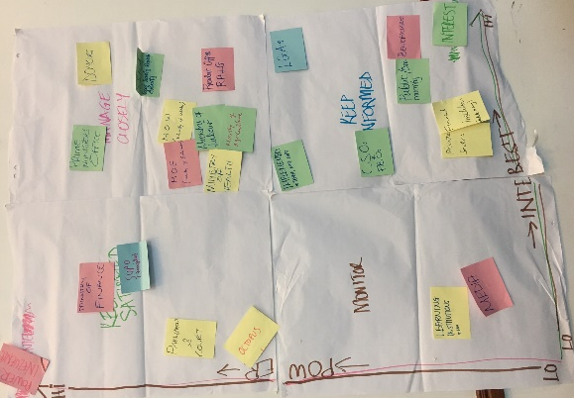
Preparation: Explain matrix for stakeholder analysis on slide using slide notes... ask them to think about their country and brainstorm all potential stakeholders that ‘have a stake’ in social protection reform (government, private sector, civil society etc). Separate into table groups with flipcharts and cards. Ask to write their key stakeholders on cards and place them around the flipchart on their table where they will have drawn same graph as on the slide.
Prepare one large flipchart for the wall by sticking four flipcharts together (each square is one square of the matrix) as per image below (but empty!).
Process: While teams are discussing and mapping at their tables walk round and make sure all is clear.
Debrief: ask each group to present in turn adding two-three stakeholders each to the large flipchart on wall explaining why they are placing them there. The next group adds two-three more and comments on whether previous were placed ‘correctly’ according to them (get debate going!). Continue going round the room till all stakeholders are finished and then go to next slide (where are beneficiaries placed? Discuss.)

3 GOVERNANCE QUESTIONS ACTIVITY
Objective: To explore the strengths weaknesses and risks that are associated with decentralisation.
Process: Divide the participants into 3 groups. Use any method to form the groups. It could be based on interest, birthday months or colour of clothes. Distribute the question handout and give each participant his or her own copy of the question. Let the groups choose a chairperson and a group spokesperson who will present on behalf of the group. The group should understand the question before they tackle the assignment. Put me the responses on the cards. One idea per card.
Debrief:
Decentralisation
As decision making authority moves away from the centre the risks in terms of policy incoherence increase and quality control cannot be guaranteed. So it is important to continuously train the agencies so that quality control is maintained.

Delegation (Stanfield??)

Coordination
Questions (Print as handouts):
- Why coordination is important for the SP system?
- How line ministries work to effect coordination (Horizontal coordination)?
- Why is it difficult to coordinate?

Support materials (print as handouts):
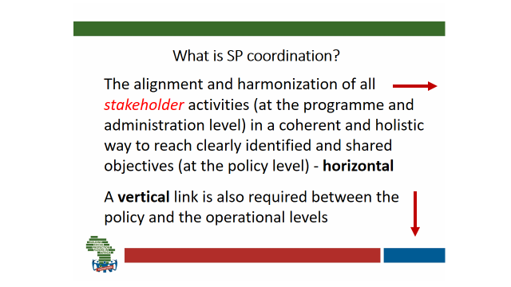
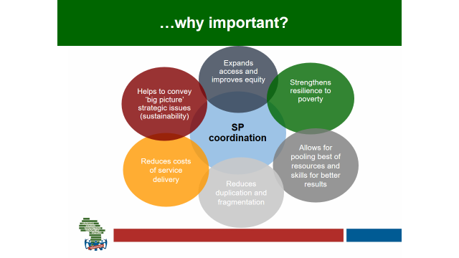

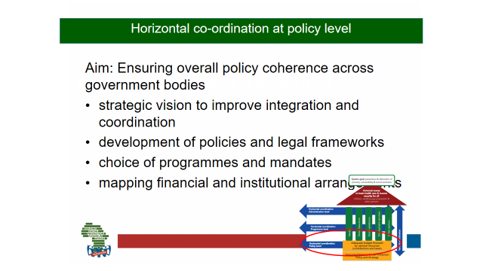
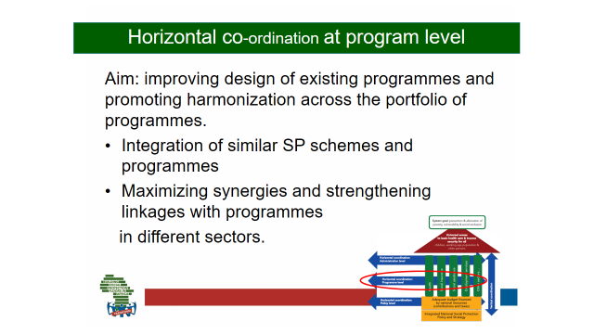

TRIPLE ‘A’ ACTIVITY: EXPANDING THE FISCAL ENVELOPE-SIMPLIFIED VERSION

Purpose: To reflect on the barriers and enablers to expanding the financial envelope from a political economy perspective – assessing real feasibility and achievability of 8 different options. These are the Triple A Cards containing financing options to be used:
Lobbying for increased aid and transfers | Reprioritising public spending
Eliminating illicit financial flows | Increasing tax revenues
Borrowing or restructuring debt | Using fiscal and foreign exchange reserves
Adopting a more accommodating macroeconomic framework | Expanding social security coverage and contributory revenues

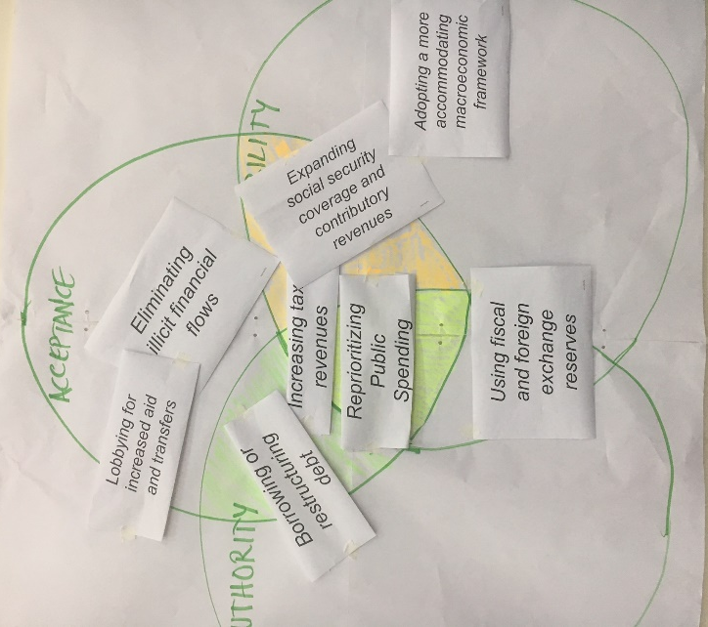
Preparation: Tape 2 flipchart sheets together (portrait orientation to obtain a large square) and draw the three interlocking circles on them, giving each circle a name: ACCEPTANCE, AUTHORITY, ABILITY. Post this poster on the wall for all participants to be able to gather in front of it during this activity.

Process: Invite participants to study the slide with the three interlocking circles of Acceptance, Authority, and Ability. Explain each using questions within the boxes as a guide Distribute one card to each volunteer. Then ask the volunteers to reflect and share their response by raising their hand. First they should say as from which perspective they are responding (Are they Government, NGO). They should say if the financing option is acceptable, they have the authority and they have the ability to pursue it. Then they should go and paste the card on the Triple A big flip chart.
Debrief: Invite each group to stand up and present their ‘answer’ to the plenary, sticking their card on the spot within the circles they have chosen. Ask whether others in the room agree or disagree… get a debate going! Once all eight options have been assessed, see whether there are any in the central ‘sweet spot’ and ask whether those appear to be truly feasible… and whether they should be therefore prioritised?
Modified Process for Policy Level:
Ask for 8 volunteer participants; give them 1 card each and ask each to read the card they are holding loudly across the room and say whether in his/her capacity as policy maker she/he can apply that financing option and analyse it based on Triple A criteria.
Debrief: Document and observe the discussions for some learnings and key lessons/observation.

Weaving it all together on the SP Web

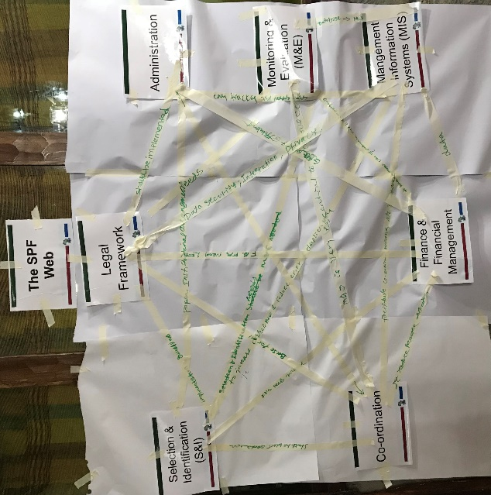
Purpose: Participants understand that all SP elements are interrelated, and that those interrelationships are as important as the individual elements, and form a complex web, which makes any SP System a ‘Living System’.
Preparation: Assemble all the SP Key take-out posters for the different topics covered throughout the previous days close to the SP Web poster (which was introduced on Day 1 of the training already).

Process: Spend about 3 min revisiting all the SP topic key take out posters. Then explain that we are now returning to the SP Web to complete all the ‘systemic’ interdependencies, relations and connections – based on the takeaways, insights and mind-set shifts relating to all the topics covered throughout the previous days and what you know now.
Ask the delegates: Draw a picture of you on a block that you think you belong and continue to link with who you individually think you are linked in the work you do?

Then introduce and play the videoclip How Wolves Change Rivers (4m33s) as a practical example of a real web operating (for wolves in nature) and how linkages can be complex, developments and shifts in the living system unforeseen and powerful beyond expectations.
Emphasize that our role as SP practitioners is more that of system developers rather than machine operators.
Spend 15 minutes in a mind mapping style plenary inviting participants to gather in a semi-circle with their chairs facing the SP Web poster, and taking turns to contribute their ‘systemic’ interdependencies, relations and connections – keep recording them all on their behalf labelling each connection/arrow on the web, or invite participants to take turns in contributing to the web themselves one after the other.
Activity Debrief: Ask participants to share which relations and interdependencies have been most useful to discover for them as practitioners.
Learning Debrief: Ask participant what specific actions they will undertake to improve these interdependencies in their own SP work context.

IDENTIFY SOCIAL PROTECTION REFORMS
Objective: To reflect on the barriers and enablers to expanding social protection provisions in their specific countries of work in terms of coverage and quality of benefits from the standpoint of the individual policy makers and their mandate – assessing real feasibility and achievability.

This is a new activity that utilizes the Triple A; it is an individual (Not group) activities:

1. Delegates are individually requested to identify a Social Protection reform
2. They are then asked to apply the Triple A criteria. They could identify reforms like,
Create SP agency, develop a social assistance act, develop a SP coordination unit, a SP policy etc.

Learning Debrief: Ask the participants to share their experience for the activity. Document key challenges faced despite the mandate they have. Document some best practices. What are some of the key takeaways?

Individual Transfer Actions
Purpose: Participants identify the 3 most important and realistic individual transfer actions that they commit to undertake as a result of the learning and transformation experienced during the training week.

Process: Start by briefly introducing Kotter’s 8 step model for change: 1. Establish/Create urgency, 2. Create/Form a guiding/powerful coalition, 3. Create a vision for change, 4. Communicate the vision, 5. Remove obstacles/empower others, 6. Create short term wins, 7. Consolidate/Build on the change, 8. Anchor the changes in corporate culture/anchor new approaches.

You may want to read up in more depth using this source: https://www.kotterinternational.com/8-steps-process-for-leading-change.

Now invite participants to if they wish use Kotter’s ‘7 steps of change’ framework to develop a ‘next steps’ plan and get practical about how they themselves might initiate and support transformation in their own SP context.

Based on your leadership and transformation and experiential learning journey in the two days Where can you make the most meaningful and transformative contribution to the SP system as an individual?

Give them about 5 min to think about where they can make the most meaningful and transformative contribution to their SP system as an individual, based on all the insights and learnings they gained throughout the training.

Ask them to identify the 3 most important and realistic action steps they are willing to undertake in their personal capacity, and then give them about 12 min. to record and elaborate on their top 3 actions using the Individual L&T Action Plan forms (one per participant).
Debrief in pairs: Participants are invited to pair up with someone else to share (on a voluntary basis) and discuss some of the action steps they have identified and how to hope to realise them

Plenary Debrief: To invite participants to share some of their action steps that they would like to find synergies or request support from others for.

